1. **Temperature sensor**

Insert data sheet:

<https://makerselectronics.com/product/dht11>

<https://makerselectronics.com/product/dht22-digital-temperature-and-humidity-sensor>

1. **Ultra-Sonic**

Insert data sheet:

<https://makerselectronics.com/product/ultrasonic-sensor-hc-04>

<http://www.ekt2.com/pdf/412_CH_ULTRASONIC_MODULE_4PIN_WATERPROOF.pdf>

>>>>>>>>>>>>>>>>>>>>>>>>>>>>>

1. **ESP**

Insert data sheet:

<https://www.handsontec.com/pdf_learn/esp8266-V10.pdf>

>>>>>>>>>>>>>>>>>>>>>>>>>>>>>

1. **Relay Module**

Insert data sheet:

<https://www.gearbest.com/relays/pp_219173.html>

>>>>>>>>>>>>>>>>>>>>>>>>>>>>>

1. **Motor Driver**

Insert data sheet:

<https://www.robotshopl.com/media/files/pdf/datasheet-1182.pdf>

p.s: MS1 MS2 MS3: on ground

>>>>>>>>>>>>>>>>>>>>>>>>>>>>>

1. **Buck converter**

Insert data sheet:

<https://www.walmart.ca/en/ip/HW-514-5A-Constant-Voltage-Constant-Current-Step-down-Power-Supply-Module-With-USB-Port-Power-Bank-Conversion-Board/PRD636YZPPAV5SZ>

>>>>>>>>>>>>>>>>>>>>>>>>>>>>>

1. Air quality:

<https://makerselectronics.com/product/mq-135-air-quality-sensor-module>

1. **Pins**

|  |  |  |  |
| --- | --- | --- | --- |
| **Sensor** | **Signal Pin** | **Supply** | **Source** |
| Temp 1 (DHT11) | 22  34  **Approved** | 5V, GND | Buck |
| Temp 2 (DHT11) | 23  40  **Approved** | 5V, GND | Buck |
| Temp 3(DHT22) | 24  42  **Approved** | 5V, GND | Buck |
| Ultra-Sonic 1 | 25 Trigger  26 Echo  24 Trigger  **Approved** | 5V, GND | Buck |
| Ultra-Sonic 2  **sr04t** on board  check the pin assignment in data sheet | 27 Trigger  28 Echo  32 Trigger  30 Echo  **Approved** | 5V, GND | Buck |
| Reserved sensor | 29  48  **Approved** | 5V, GND | Buck |
| ESP | 1 RX  0 TX  Is it required to add the board embedded to the PCB? **Yes** | 3.3 V , GND | Arduino |
| Relay Module 1 | 30 ->37  23,25,27,29,31,33,35,37  **Approved** | 5V, GND | Buck |
| Relay Module 2 | 50-> 53, 10,11,12,13  39,41,43,45,47,49,51,53  **Approved** | 5V, GND | Buck |
| Motor Driver 1 | 19 Step  18 Dir  49 -> ENABLE  Does it require any PWM pins?(General comment for all drivers)  22 -> Enable(General comment for all drivers)  **Change Pin 49 -> 22**  **Approved** | 5V, GND  12V, GND | Buck  Main source |
| Motor Driver 2 | 2 Step  3 Dir  49 -> ENABLE  Note: This is an Interrupt pin.  **Pin 2 is an analog pin as referred in the bellow diagram** | 5V, GND  12V, GND | Buck  Main source |
| Motor Driver 3 | 4 Step  5 Dir  49 -> ENABLE | 5V, GND  12V, GND | Buck  Main source |
| Motor Driver 4 | 6 Step  7 Dir  49 -> ENABLE | 5V, GND  12V, GND | Buck  Main source |
| Air Quality | 54 Analog pin  29 digital pin  Pin 54 doesn’t exist.  Should it be replaced by an analog pin?  52 Analog pin  50 digital pin  **Use any available combatable Pins with the module** | 5V,GND | buck |

1. **Requirements**

* Protection Fuse will be added on input terminal, after calculating the Input current from all sensor
* Protection Fuse will be added separately for Arduino
* Operating Switch for Arduino
* Operating switch for the system
* Labels shall be added for each sensor
* Data cables shall be used to connect for sensor (polarized)
* Buck will be added on the same board (output to power distribution circuit via yellow Rosette)
* Board shall be green masked
* Indication LEDs (RED) shall be added one for each and labeled (Arduino, driver, system)
* Arduino shall be supplied by 12 V directly
* Motor drivers are connected to the same Enable pin (49).
* Motor drivers shall have 4 output pins to connect the stepper motor as referred to the datasheet.
* Minor change regarding the ultra-sonic we will use a different module that can be embedded on the board.

Current design: 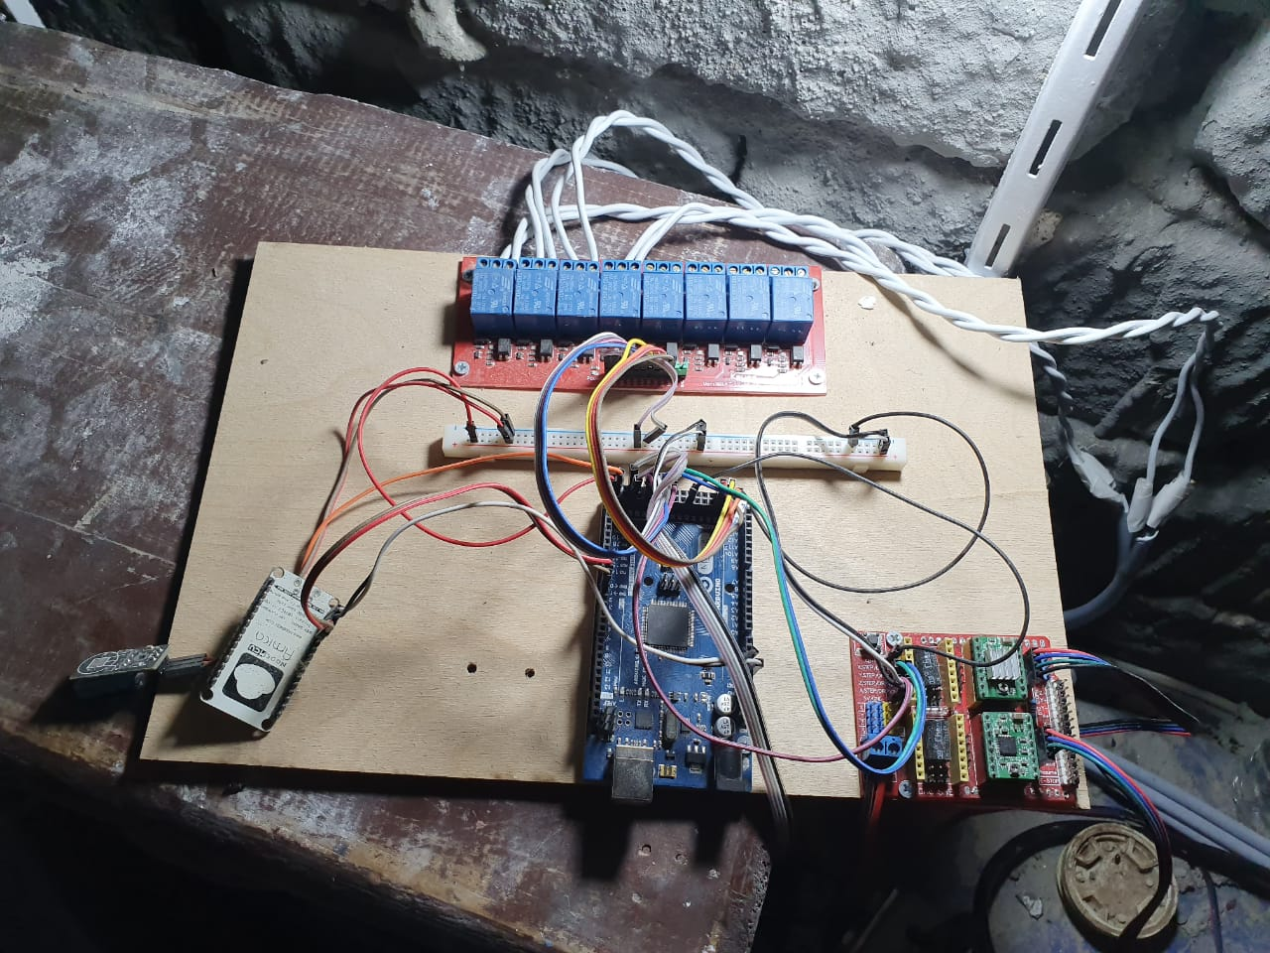

<https://www.make.net.za/wp/wp-content/uploads/2016/08/arduino-mega-pinout-diagram.png>